OBSERVATION OF VARIOUS DAYS OF NATIONAL IMPORTANCE IN THE MONTH OF JANUARY 2021
Mrs B Kalyani- NSS Programme Officer.

“Our Dr C Sobhanadri Siddhartha College of Nursing NSS unit celebrated various days of National Importance in the month of January -2021.
S.no | Description | Date | Beneficiaries
1 | Observation of National youth week celebrations | 12.01.2021 to 19.01.2021 | 150
2 | National Voters day | 25.01.2021 | 370
3 | Republic day | 26.01.2021 | 375

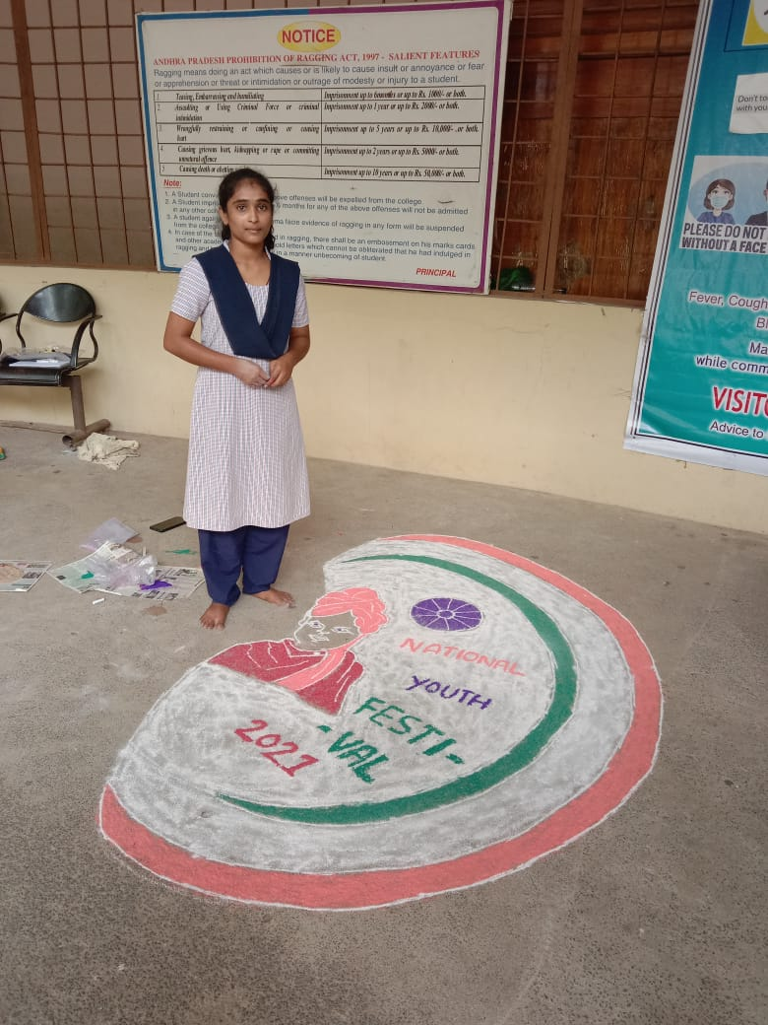

Fig - 1 (a) : On occassion of National Youth festival conducted rangoli competion
Ms M Anusha , 3rd year b.sc nursing student received 1st prize

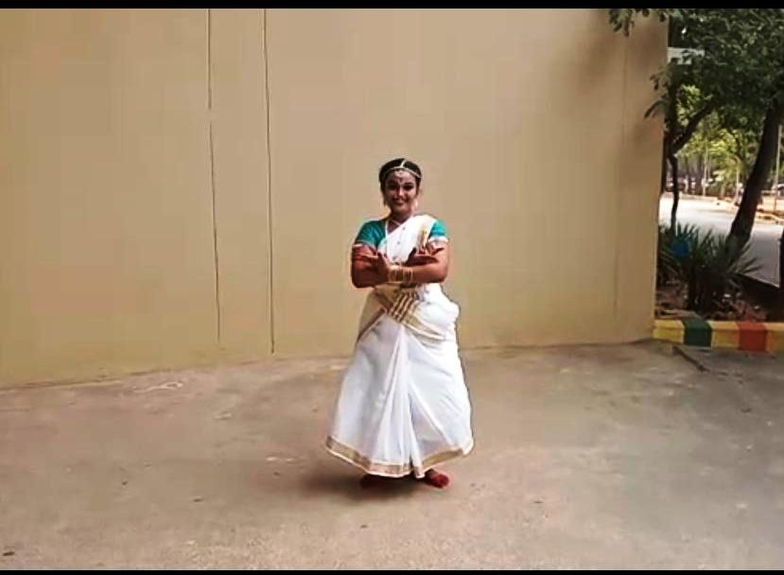

Fig – 1 (b) : On occassion of National Youth festival conducted Dancing competion Ms Lekshmi babu 2nd year b.sc nursing student received 1st prize
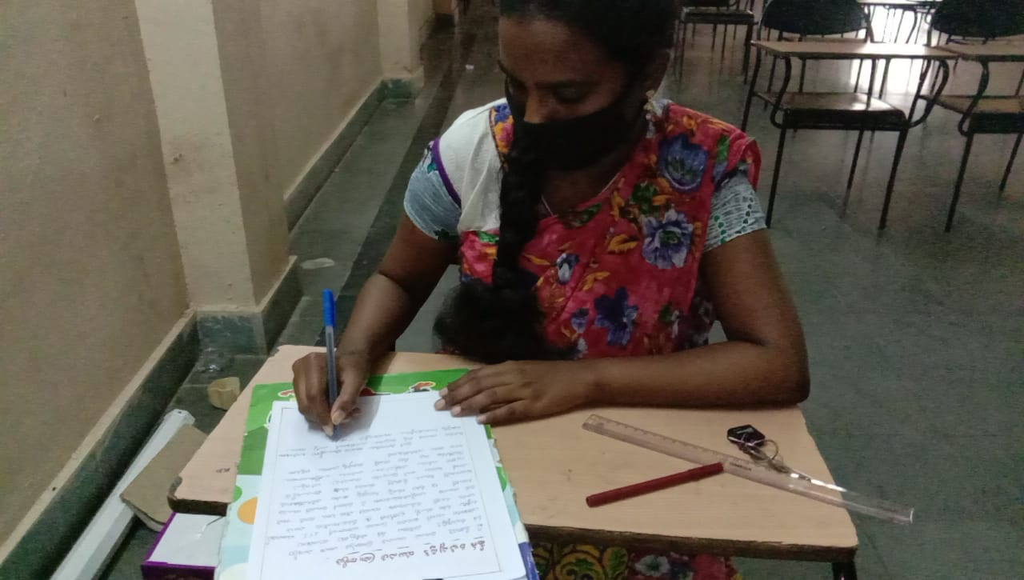

Fig – 1 (c) : On occassion of National Youth festival conducted Essay writing competion Ms J Bhavani, 2nd year b.sc nursing student received 1st prize

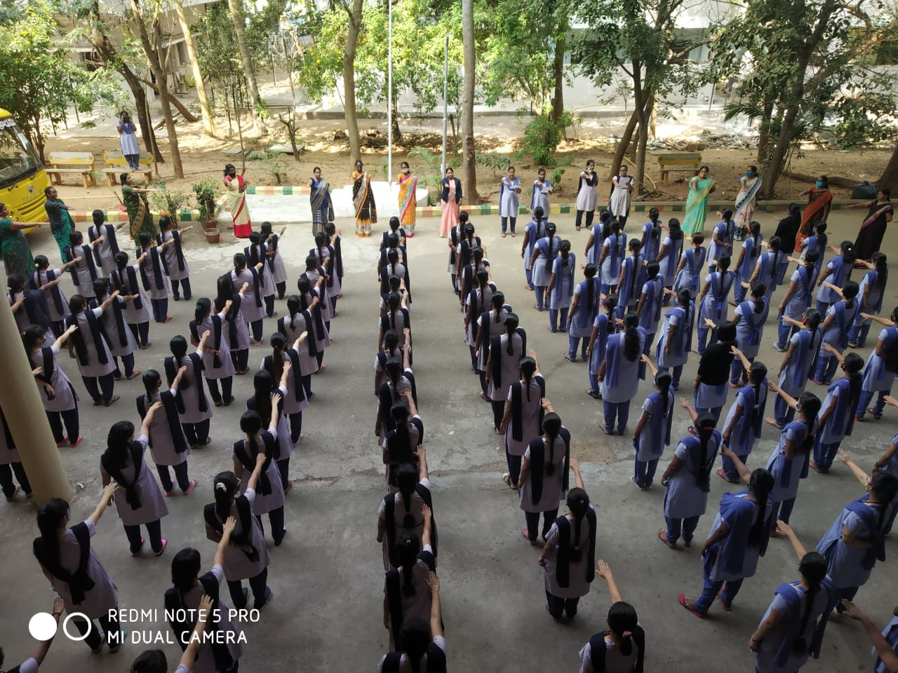

Fig-2 (a) : National voters day ooath taken by Siddhartha college of nursing Principal , Staff,
NSS volunteers

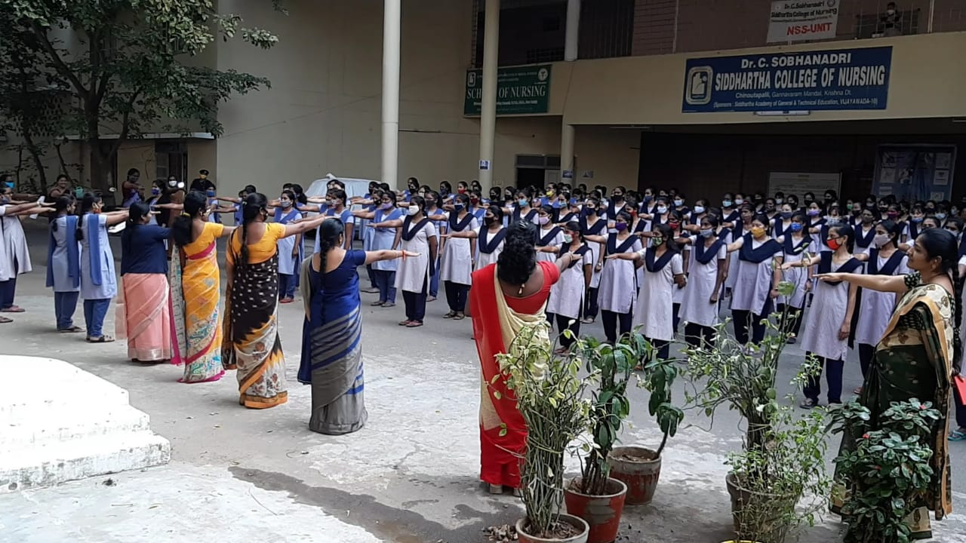

Fig-2 (b) : National voters day oath taken by Siddhartha college of nursing Principal
Mrs J Vandana ( 4th right) , Staff – NSS volunteers-2

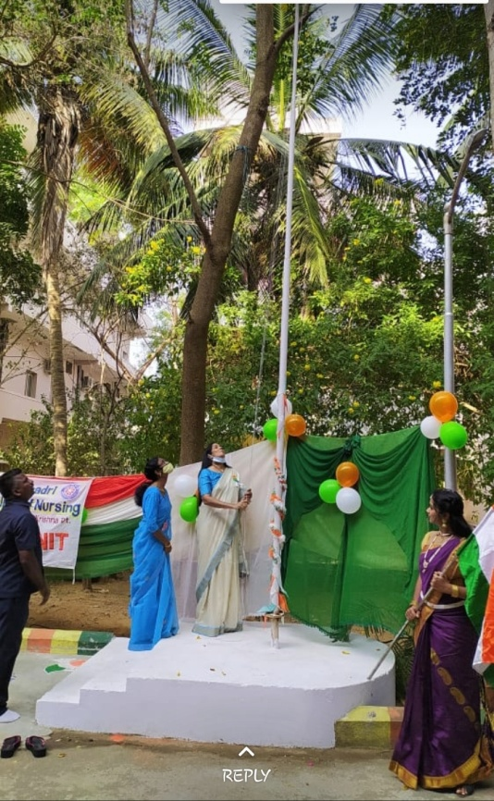

Fig -3 (a) : Siddhartha College of Nursing celebrated the republic day celebrations National flag hosted by Smt V Sasi Kala , Convenor ( Flag hosted person) , Principal Mrs J Vandana , college staff and NSS volunteers participate.

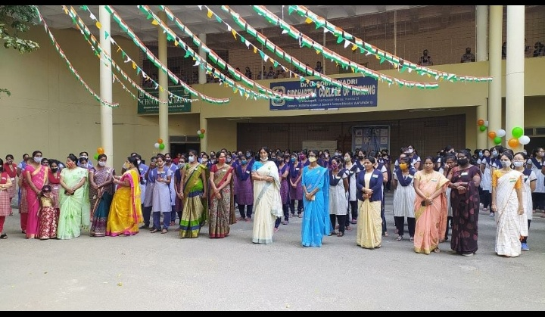

Fig -3 (b) : Siddhartha College of Nursing celebrated the republic day celebrations National flag hosted by Smt V Sasi Kala , Convenor , Principal Mrs J Vandana , college staff and NSS volunteers -2

